Jialin Yang

Manual Test Plan

1. When first open the app

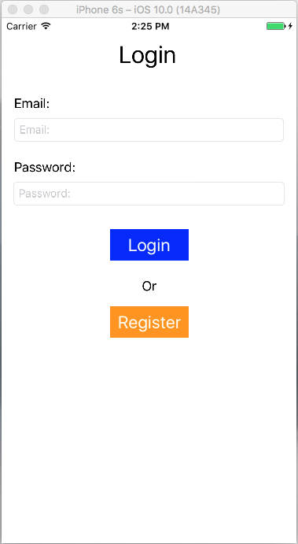

1. Clicked “Login” button

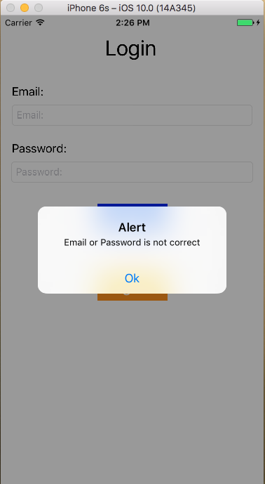

1. Clicked “Ok” then “Register” button

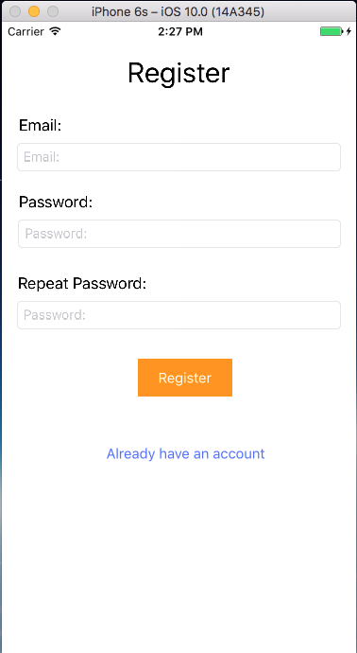

1. Enter Email, Password, and Repeat Password.

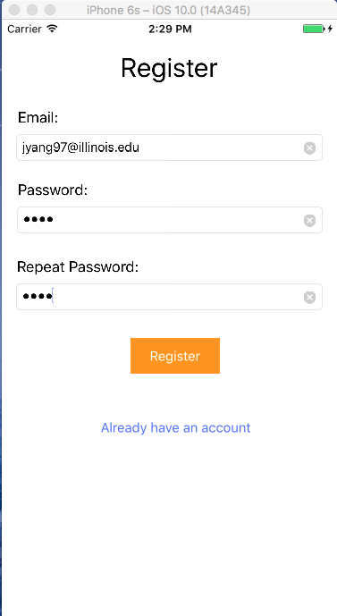

1. Error for empty input

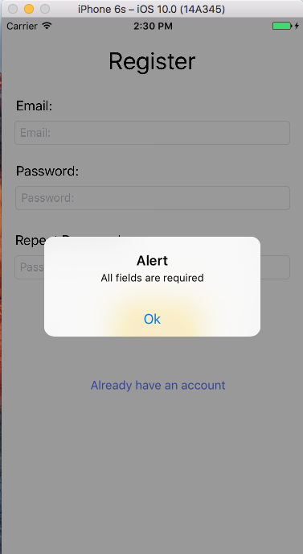

1. Error for passwords not matching

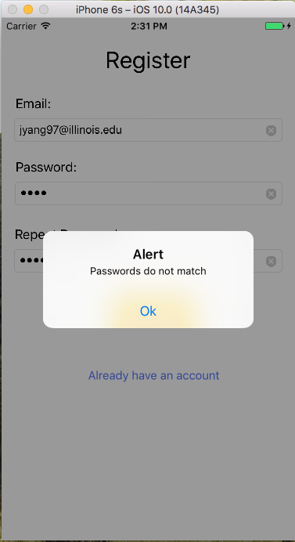

1. Alert for user already exist

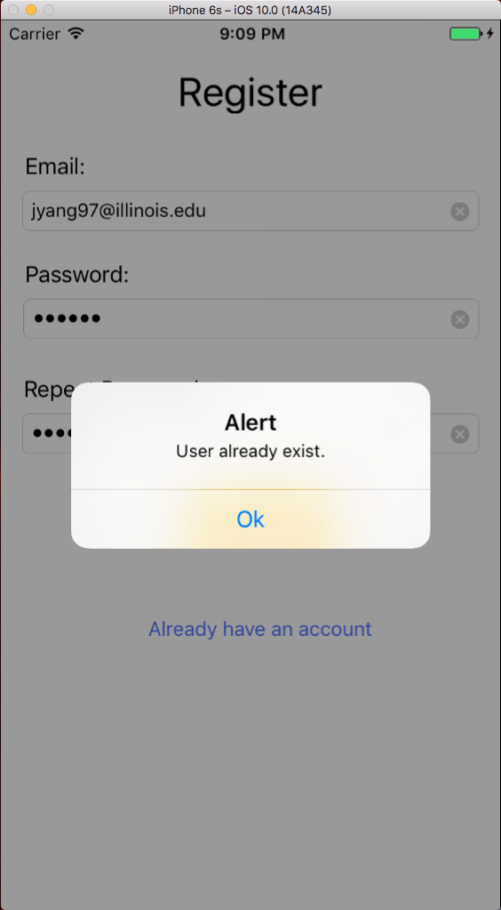

1. Alert for registration complete after click “Register” button

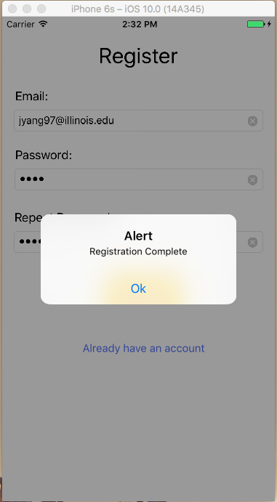

1. Clicked “Ok” and fill out Email and Password to login

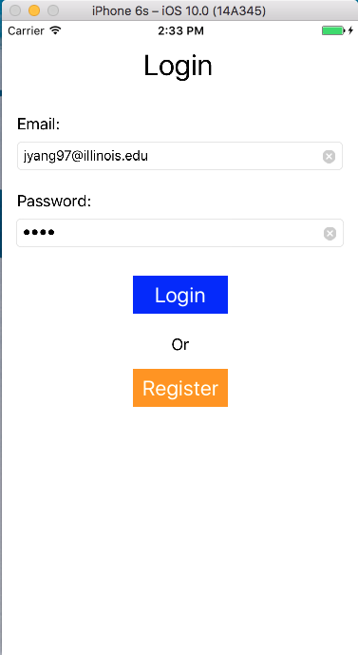

1. Error for Email or Password is not correct

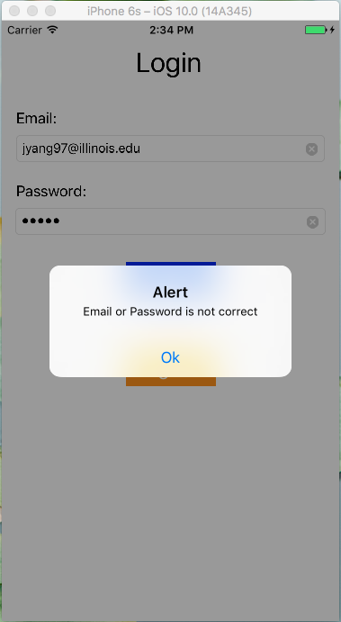

1. Home page appears after login

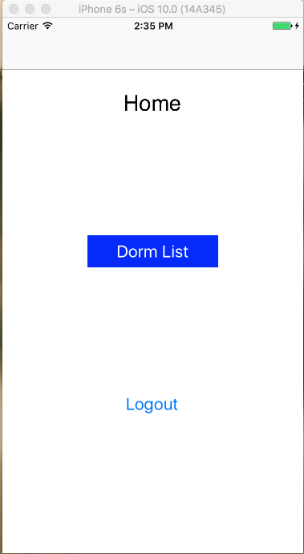

1. Clicked “Dorm List” button

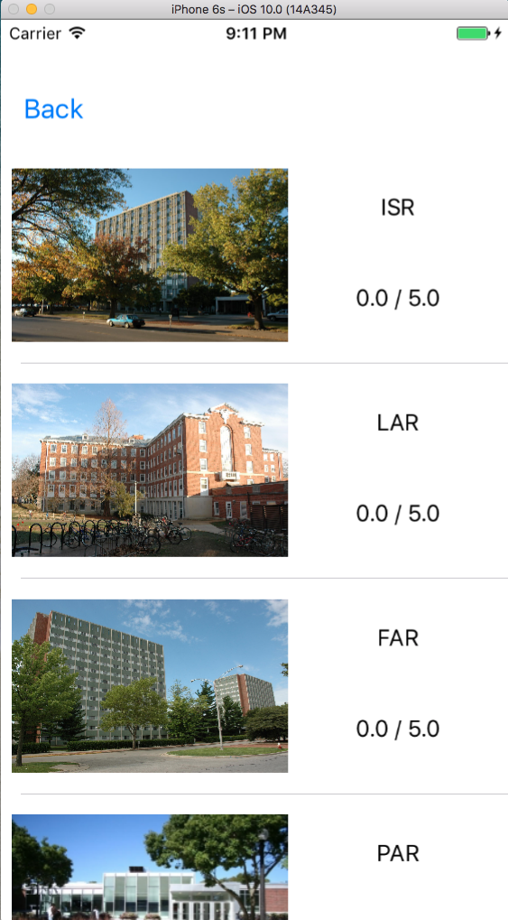

1. Clicked “ISR” cell

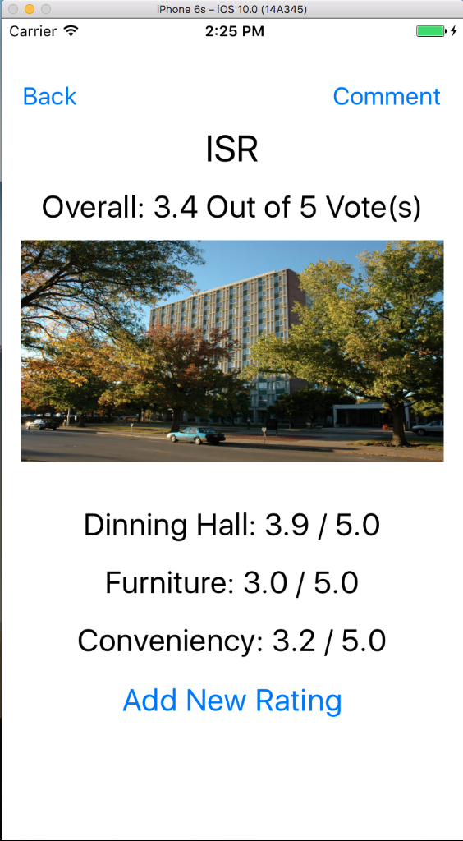

1. Clicked “Add New Rating”, click “Submit” button to upload to database

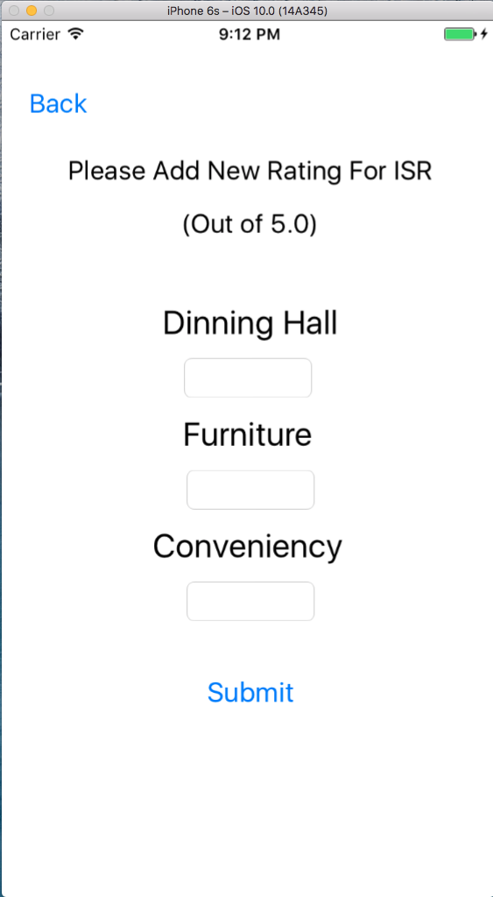

1. Invalid input will not add into database and automatically “Back” up



1. Clicked “Comment” button to go to comment list

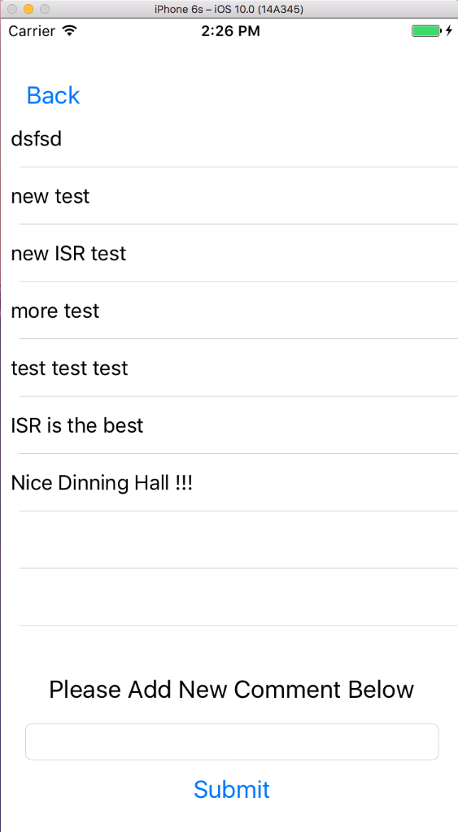

1. Put down new comment in the text field and clicked “Submit” button will add new input to the database and output in the top of the comment list

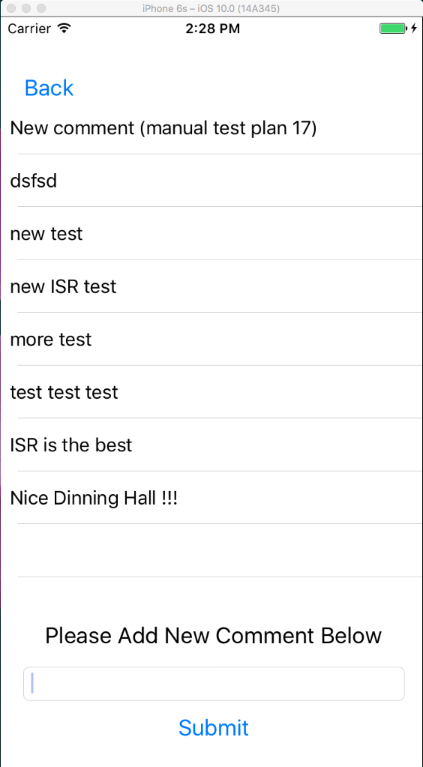

1. Clicked “Back” button to back to current dorm page

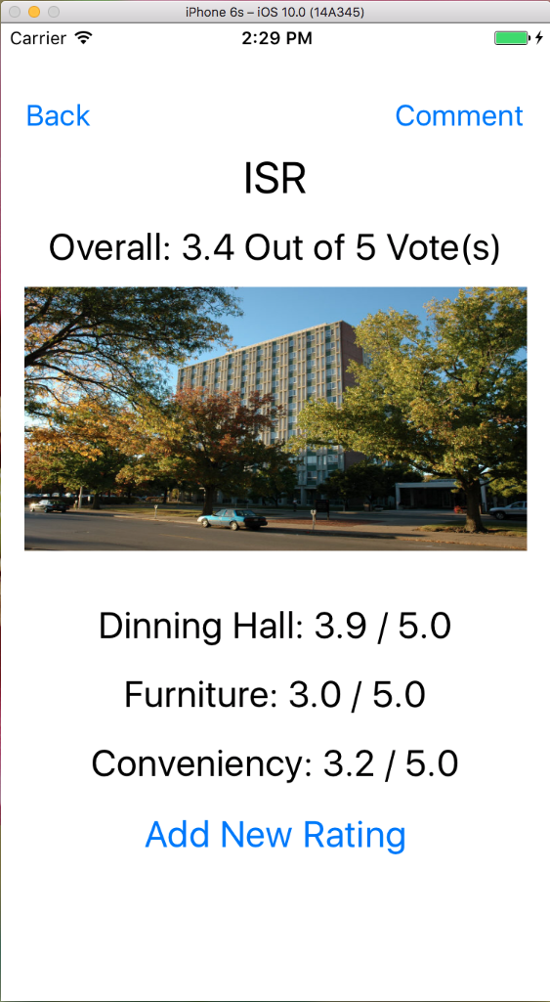

1. Clicked one the Image to enter the photo list

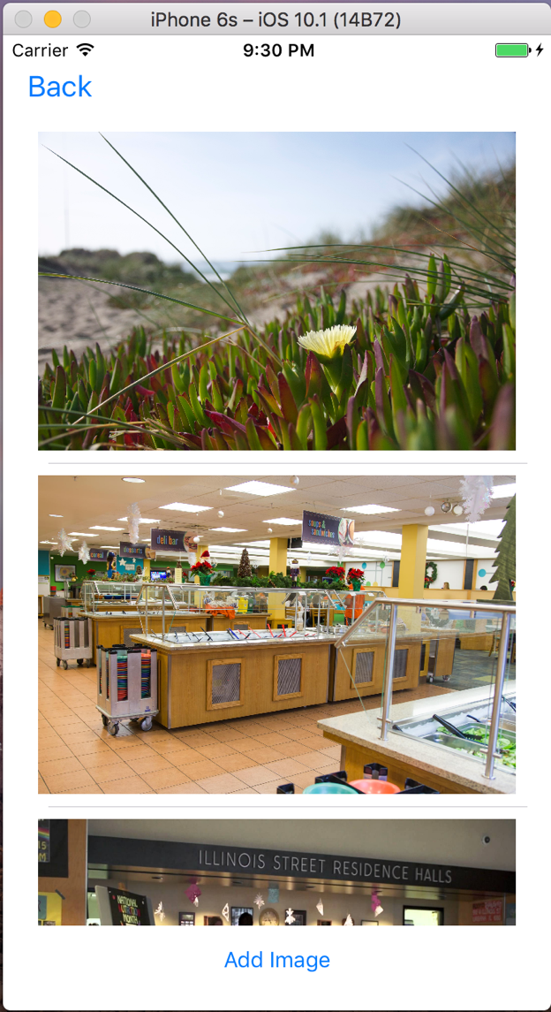

1. Clicked “Add Image” to add photo from Photo Library

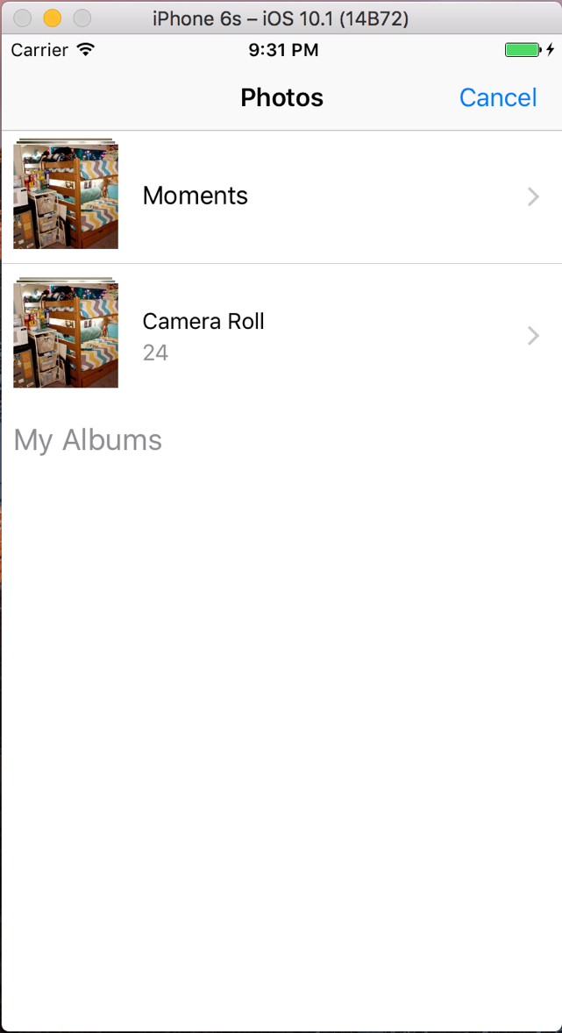

1. Clicked “Back” button twice to back to home page, then clicked “Logout” button

